

**Green University of Bangladesh**

**Department of Computer Science and Engineering (CSE)**

**Faculty of Sciences and Engineering**

**Semester: (Summer, Year:2022), B.Sc. in CSE (Day)**

**LAB PROJECT PROPOSAL**

**Course Title:** Object Oriented Programming Lab

**Course Code:** CSE-202 **Section:** D4

**Project Name:** Student database management system.

**Student Details**

|  |  |
| --- | --- |
| **Name** | **ID** |
| Tarikul Islam | 212002008 |

**Lab Date** : 21-07-22

**Submission Date** : 11-08-22

**Course Teacher’s Name** : Ms. Ayesha Khatun.

[For Teachers use only: Don’t Write Anything inside this box]

|  |
| --- |
| **Lab Report Status**  **Marks:** ………………………………. **Signature:** …………...  **Comments:** …………………………... **Date:** ………………... |

1. **TITLE OF THE PROJECT PROPOSAL:**

Student database management system.

1. **PROBLEM DOMAIN & MOTIVATIONS:**

• Regularly uses manual data handle is so taupe, painful and time killing method. Avoid this type of data handle and easily access all type of data handle in computer basis and safe our time.

• Easily create data table and adding, deleting and searching any data value easily and its safe our time.

**3. PROJECT INTERFACE:**

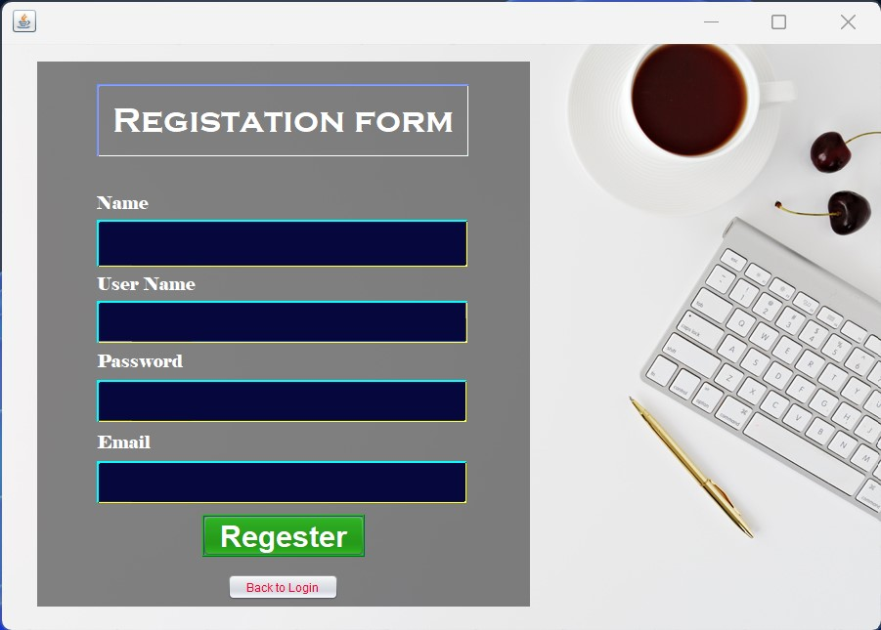

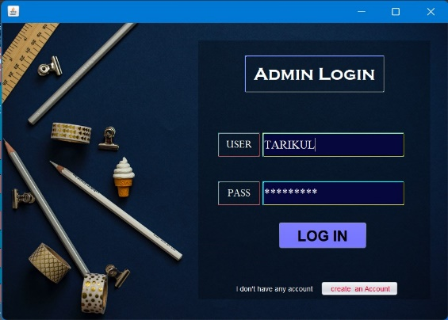

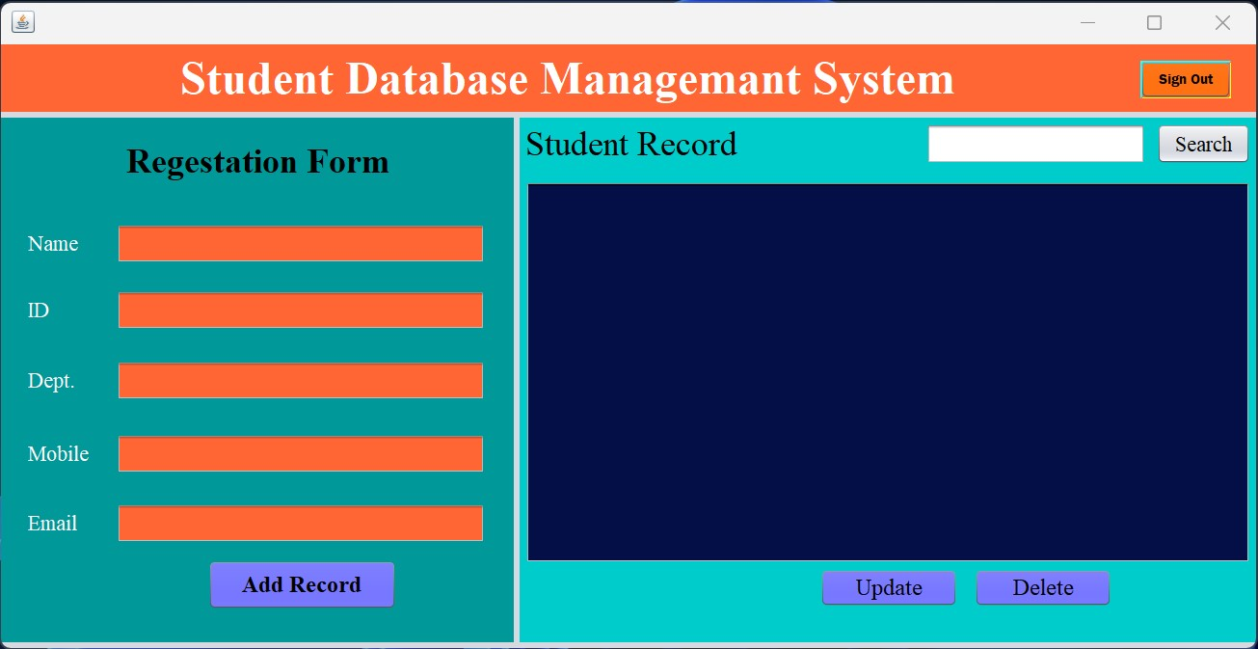

**4. OBJECTIVES/AIMS:**

• Easily handling any type of data according to user satisfaction.

• Finding, inserting and deleting any data easily.

**5. TOOLS & TECHNOLOGIES:**

Using this tool to completing my project-

* NetBeans IDE 8.2.
* Programming language JAVA.
* Using Java swing
* Object oriented technique.
* File Handling.

**6. CNCLUSION:**

In this project, I will be using Java programming language and java swing to create this program. In this program using any type of database management system and handle all of data insert, delete and searching